Reading and Writing NAACCR V26 XML Data Files Using SAS
Update 2026-07-30 for v12.4

Step 1. Learn about NAACCR XML.
Before you get started, you may want to read more about the NAACCR XML standard, here:
https://www.naaccr.org/xml-data-exchange-standard/

Step 2. “Git” some tools.
SAS and XML are not best of friends, so reading and writing NAACCR V21+ files using SAS is more involved than the previous NAACCR versions that supported .csv or other “flat” files. To help SAS and XML get along, you will need some tools, including SAS Macros, that were written by Fabian Depry at IMS. [Thank you, Fabian!] Navigate to the NAACCR-XML Java Library on GitHub (https://github.com/imsweb/naaccr-xml). The GitHub project will allow you to access a Java library for reading and writing NAACCR XML. The previous versions of the macros don't support NAACCR 26 properly and should be replaced by this version.

- Download and “install” the latest version of the naaccr-xml-utility file from: https://github.com/imsweb/naaccr-xml/releases. You only need to download the NAACCR XML Utility ZIP file “naaccr-xml-utility.12.4.zip”, not the source code files. As of 2026-07-01, the latest version is v12.4.

IMPORTANT NOTE: SAS 9.4 versions that precede SAS9.4 M6 use a SAS Private JRE that is based on Java 7. Beginning with the NAACCR XML macros in v11.0, Java 8 was used. This is a significant change that might create issues in some old SAS environments. For other reasons – particularly security – you should update SAS to 9.4 M8.
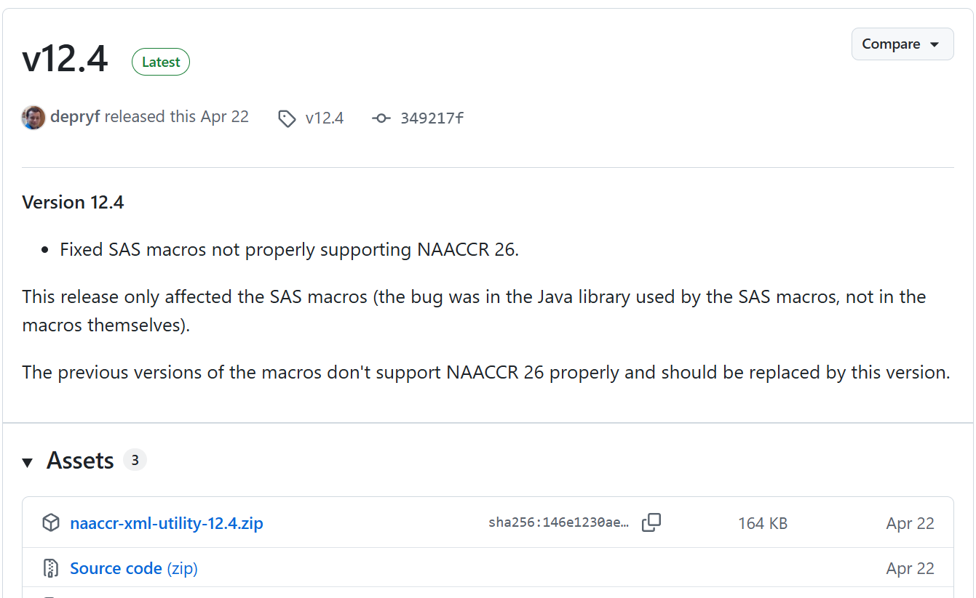
- Save the utility in any folder you like and unzip it. When you unzip the file, you will see the following structure in the destination folder:
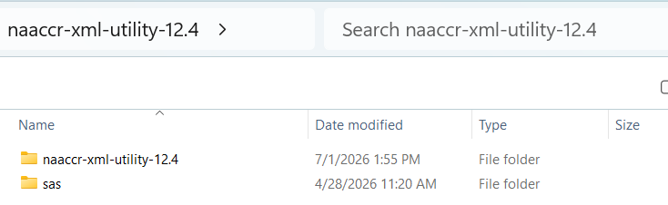

Step 3. Prepare your XML data file and the user-defined dictionary file that accompanies it (if there is one). This step “depends.” It depends on your registry software and it depends on the purpose for creating the file. Below are:
- an example using SEER*DMS,
- comments for Registry Plus CORE, and
- comments if you were “just given” a NAACCR XML data file, e.g., for a research project.

The XML data file and user-defined dictionary (likely also in XML format) come as a pair; you need the dictionary to read the data file. If the data file is a 100% standard NAACCR XML data file (Type Incidence, Confidential, or Abstract), you will only need the standard data dictionary to read your data file and will not need an additional user-defined dictionary. This is true even if your data file includes only a subset of the standard NAACCR data items. However, if your data file has any extra data items, there needs to be a second user-defined dictionary. The SEER, NPCR, and NAACCR data submissions all include non-standard fields, so all have these second user-defined dictionaries. The standard data dictionary is baked into the SAS program.

The standard NAACCR and user-defined dictionaries include a Uniform Resource Identifier (URI). The URI can be found as a root attribute of the XML dictionary. Note that the dictionary URI values might look like internet addresses, because URIs often use the same convention as URLs (Uniform Resource Locators): a path delimited by slashes, with the beginning of the path representing an organization and each remaining part of the path representing a more specific part of the resource. URIs, however, generally do not point to an existing web location. A given dictionary URI can point to an actual web location containing the dictionary, but that is not a requirement, and the URI of the standard NAACCR base dictionaries don't reference actual locations. Don't worry; your data are not being sent to a website.

<NaaccrDictionary dictionaryUri="http://naaccr.org/naaccrxml/naaccr-dictionary-260.xml"
naaccrVersion="260"
specificationVersion="1.8"
dateLastModified="2025-06-12T10:00:00-06:00"
description="NAACCR 26 base dictionary"
xmlns="http://naaccr.org/naaccrxml">
<ItemDefs>
<ItemDef naaccrId="abstractedBy"
naaccrNum="570"
a. This example is for registries using SEER*DMS who want to use SAS on a SEER Submission Extract XML file.

In SEER*DMS, navigate to View -> Reports and select EXT-02, Submission Extract. Note that the SEER, NPCR, and NAACCR submission extracts are now all part of EXT-02. After you have selected the appropriate parameters, click “Run Offline.”

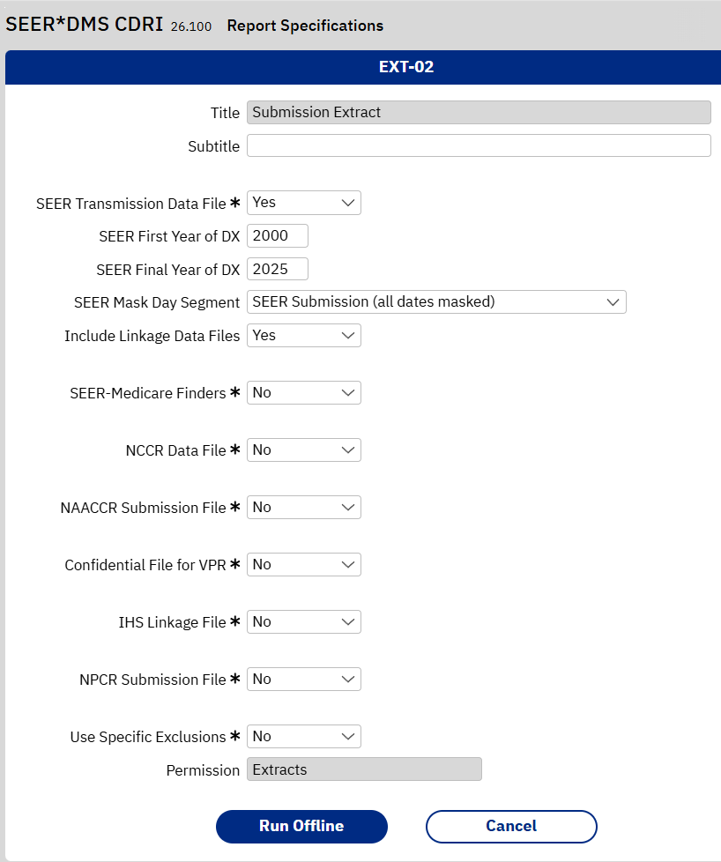

When the extract has completed successfully, download the data file, which will be G-zipped. Also download the user-defined data dictionary, which will be in both CSV and XML format. Note that the SEER*DMS EXT-02 Extract already has both the base NAACCR dictionary and the user-defined submission dictionary in CSV format, so you can skip Step 4 below. Step 4 may be needed for other SEER*DMS extracts, so is included for completeness. The SAS Macro can read XML data files in an unzipped or GZIP format, so you do not need to unzip the GZIP version that will be downloaded from SEER*DMS.
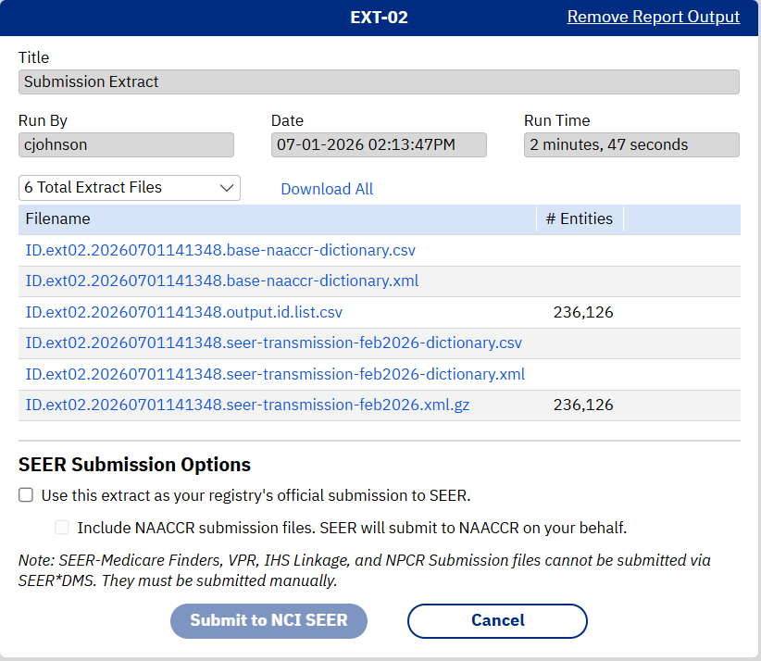

b. For Registry Plus, the Registry Plus Call for Data Extract Program for Registry Plus CORE users will create a NAACCR XML file for the 2026 data submission to NAACCR and NPCR CSS. All extracts created in Registry Plus CORE V26 will be NAACCR V26 XML data files. NAACCR XML or delimited files can be created using the Registry Plus CORE Extract Wizard to generate data files for researchers. Instructions are in the Registry Plus CORE User’s Manual. Please contact cancerinformatics@cdc.gov if there are any questions regarding Registry Plus products.
c. If you are a researcher or other who was “just given” a NAACCR XML data file, you may or may not need a second user-defined dictionary. If there were fields in the data file other than standard NAACCR fields, you will need a user-defined dictionary, which the person providing the data files should be able to provide.

Step 4. Convert the dictionaries from XML to CSV.
Dictionaries are usually in XML format, but for technical reasons, the SAS macro expects them in CSV format. Both File*Pro and NPCR XML Exchange Plus software can convert XML dictionaries to CSV format. This is only required if you have a user-defined dictionary, i.e. additional fields beyond what is included in the base NAACCR data dictionary. If that is the case, a dictionary should have been provided by the organization that created your XML data file or wrote the specifications for it. For example, the SEER, NPCR, and NAACCR data submission files will all include these user-defined dictionaries. If you already have a CSV formatted file of the user-defined dictionary, you can omit Step 4 and move to Step 5.

The first example is for File*Pro.

a. Launch File*Pro and click on NAACCR XML Dictionary Editor.
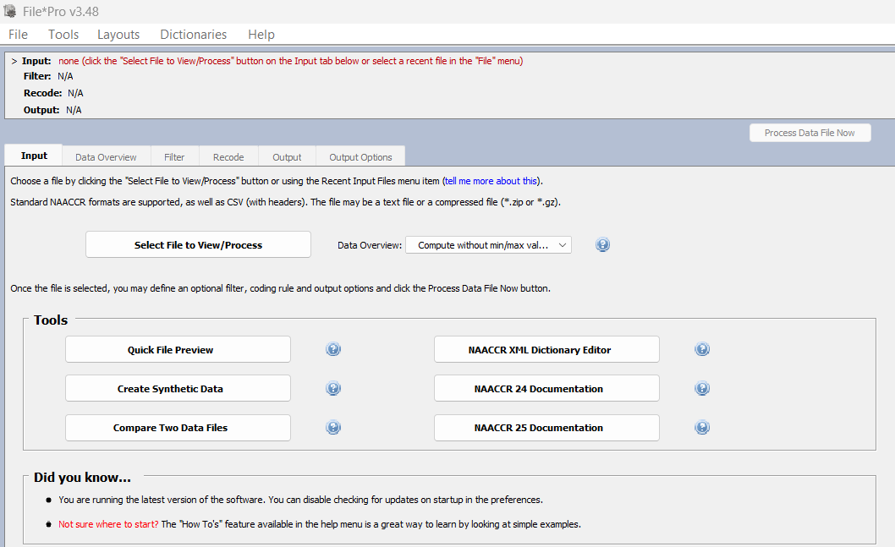

b. Click on the folder icon to Load Dictionary and navigate to the user-defined dictionary in XML format.

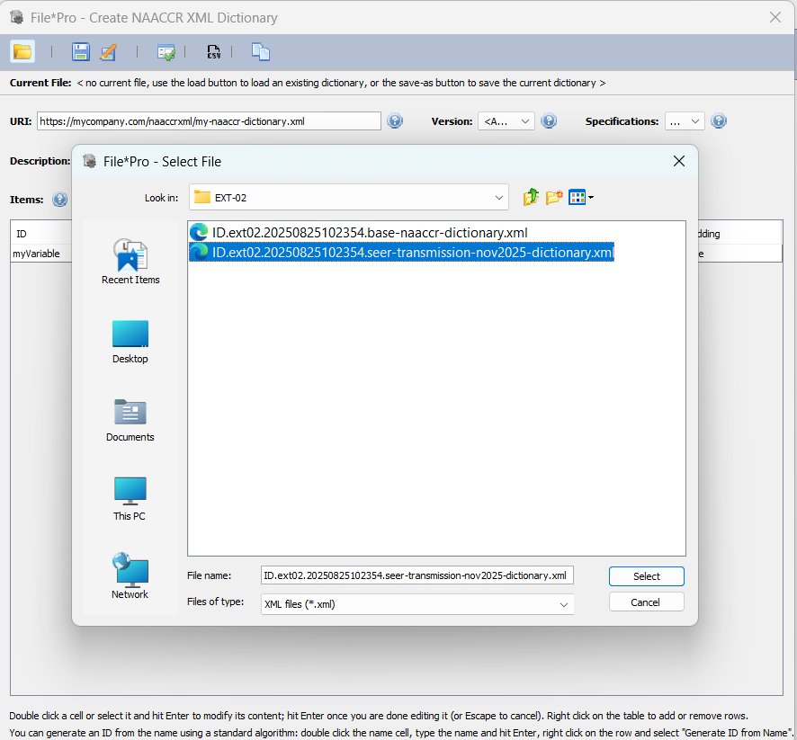

c. After the XML dictionary loads, click on the CSV icon, select the folder and filename for the CSV dictionary, and click Create CSV.
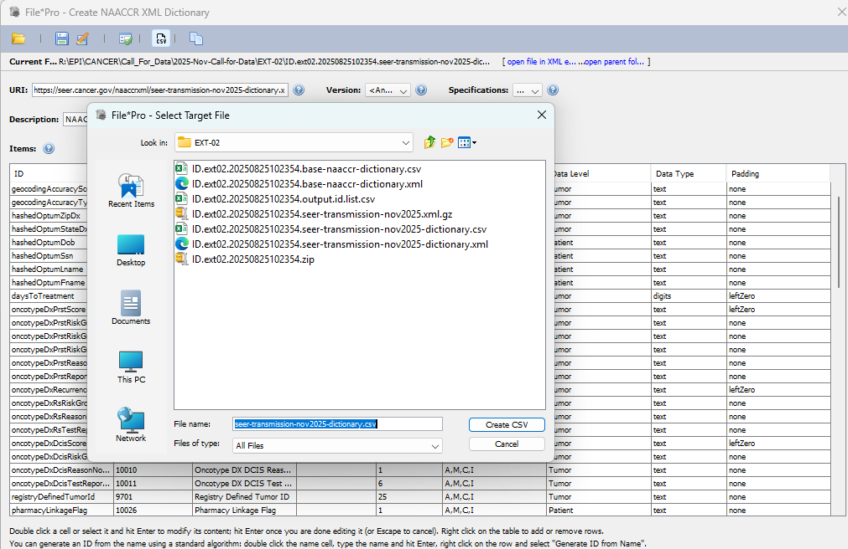

The second example is for NPCR XML Exchange Plus.

a. Launch NPCR XML Exchange Plus and click on the Maintain Dictionary icon.
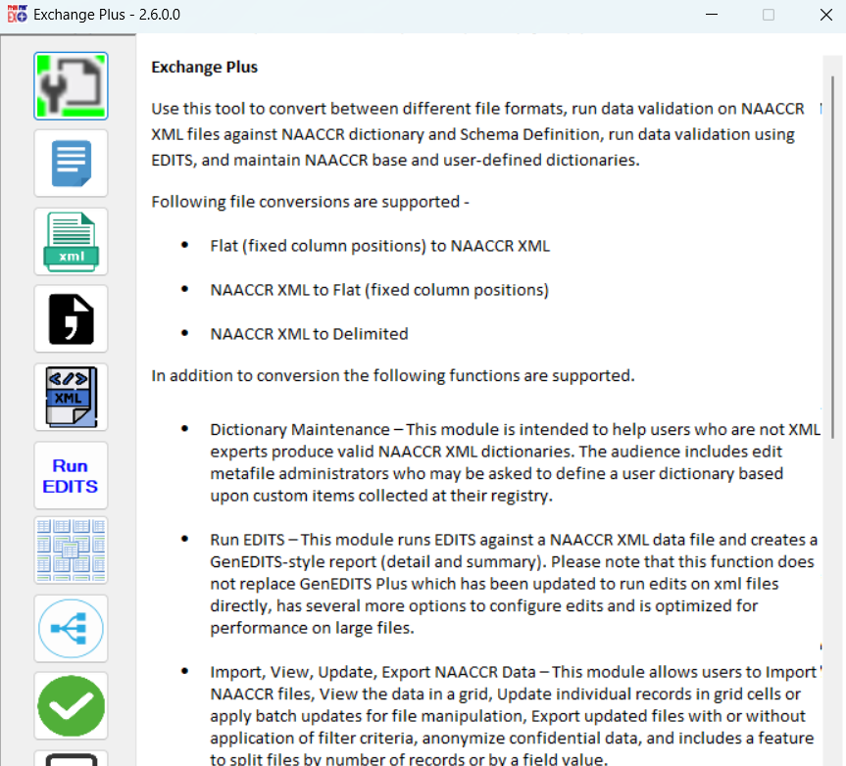

b. Browse to the Base and User-defined dictionaries in XML format. After the dictionaries load, click Export User-defined Dictionary. This will open the CSV dictionary in Excel. Save it from Excel as CSV (keep the file type the same) using the name and folder location that you choose.
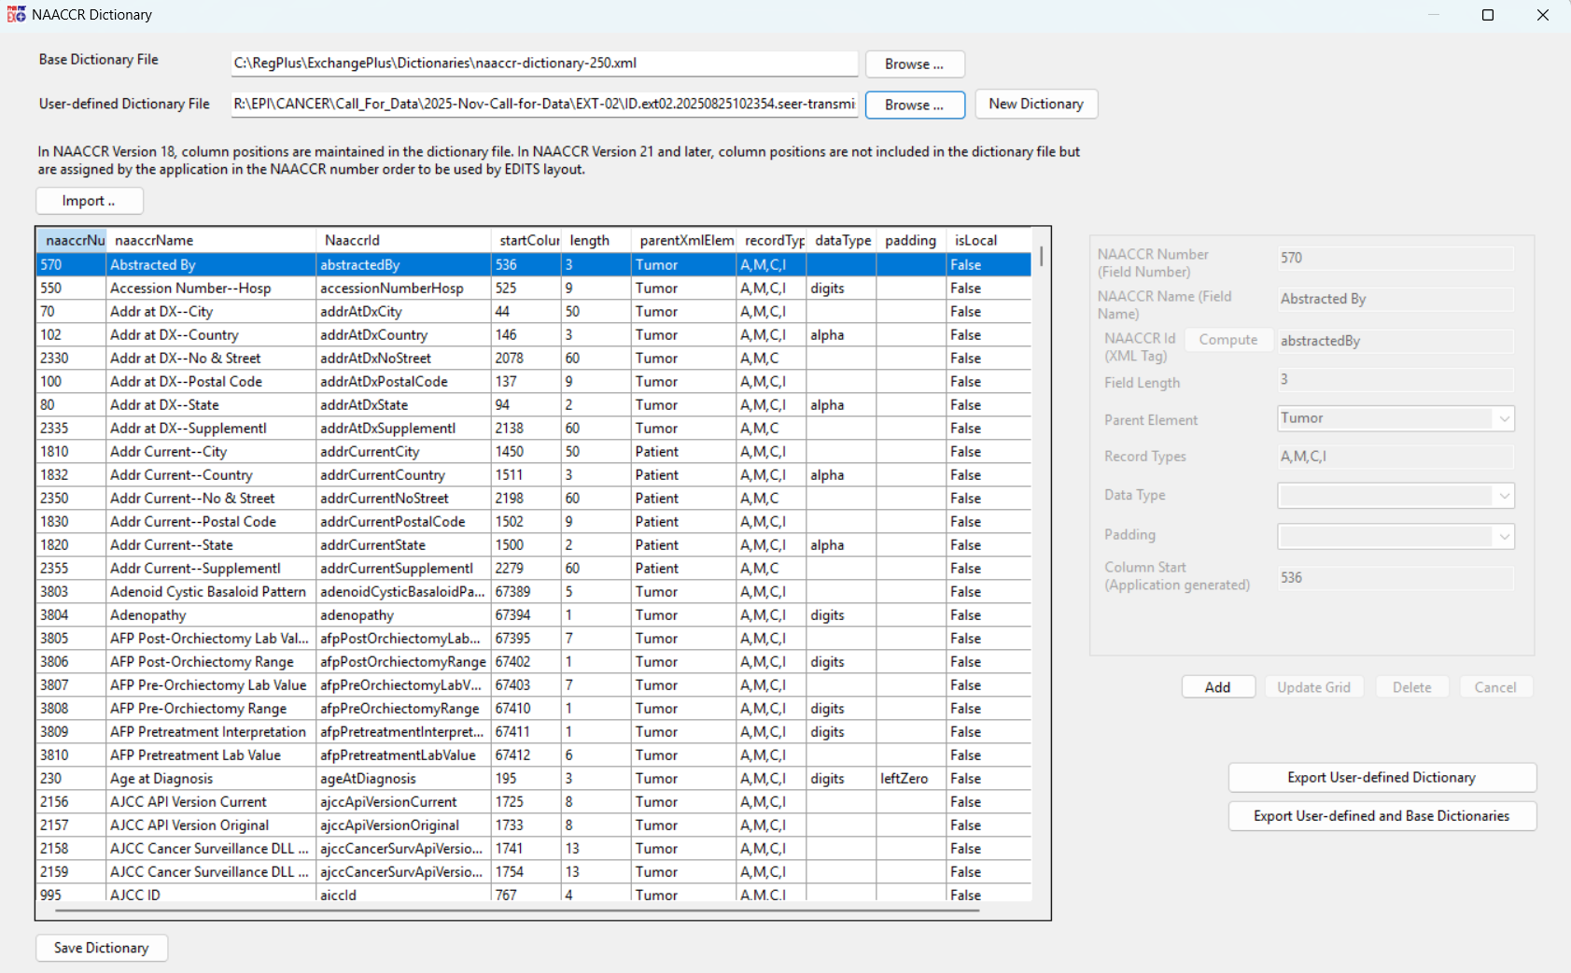

Step 5. Launch SAS.
In SAS, open ReadWrite_NAACCR_XML_tidy.sas and follow the instructions in the SAS program for modifying the code. Piece of cake, right?!


