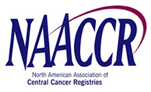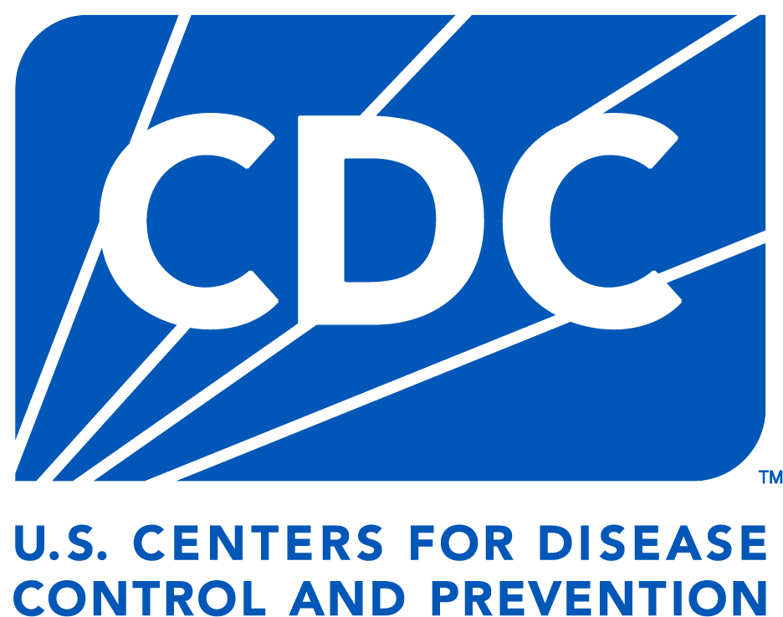

**Embargoed until 10 a.m. ET on April 21, 2025**.

|  |  |  |
| --- | --- | --- |
| **MEDIA AVAILABILITY** | |  | | --- | | **Contact:**  **NCI Press Office:** 240-760-6600, [NCIPressOfficers@nih.gov](mailto:NCIPressOfficers@nih.gov)  **ACS Press Office:** Michele Money-Carson,  813-240-0954, [michele.money-carson@cancer.org](mailto:michele.money-carson@cancer.org)  **CDC Press Office:** (404) 639-3286, [media@cdc.gov](mailto:media@cdc.gov)  **NAACCR:** Recinda Sherman, 217-698-0800 ext. 6, [rsherman@naaccr.org](mailto:rsherman@naaccr.org) | |

**Annual Report to the Nation: Cancer deaths continue to decline**

**What:** Overall death rates from cancer declined steadily among both men and women from 2001 through 2022, even during the first two years of the COVID-19 pandemic, according to the 2024 Annual Report to the Nation on the Status of Cancer. Among men, overall cancer incidence, measured as the rate of new cancer diagnoses, decreased from 2001 through 2013 and then stabilized through 2021. Among women, overall cancer incidence increased slightly every year from 2003 through 2021, with the exception of 2020. The report appeared April 21, 2025, in *Cancer*.

Progress in reducing cancer deaths overall is largely the result of declines in both incidence and death rates for lung cancer and several other smoking-related cancers, the researchers noted. New diagnoses and deaths from lung cancer, for example, have declined in both men and women over the past 20 years. Meanwhile, the incidence of cancers associated with obesity has been rising. These include female breast, uterus, colon and rectum, pancreas, kidney, and liver cancers.

The report also shows that new diagnoses of breast cancer gradually increased over the study period, but the overall breast cancer death rate decreased. Cancer death rates in children declined steadily over the study period; those for adolescents and young adults also declined until recently, when the decline slowed and stabilized. From 2018 to 2022, cancer deaths decreased for each major racial and ethnic population group. From 2017 to 2021 (excluding 2020), cancer incidence was stable among men in each major racial and ethnic population group but increased among women in each major racial and ethnic population group. During the same time period, among men, incidence was highest in non-Hispanic Black men, whereas among women, incidence was highest in American Indian and Alaska Native women.

The report also included an analysis of the COVID-19 pandemic’s impact on observed cancer incidence in individual states, the District of Columbia, and Puerto Rico for the first two years of the pandemic. Cancer incidence declined sharply in 2020, likely due to pandemic-related disruptions in health care, but returned to pre-pandemic levels by 2021. The magnitude of the 2020 decline was similar across states, despite variations in COVID-19 policy restrictions. The researchers noted that these findings underscore the importance of providing access to health care, even during public health emergencies, to ensure the timely diagnosis of cancer.

The Annual Report to the Nation on the Status of Cancer is a collaborative effort among the National Cancer Institute (NCI), part of the National Institutes of Health; the Centers for Disease Control and Prevention (CDC); the American Cancer Society (ACS); and the North American Association of Central Cancer Registries (NAACCR). The report provides annual updates on cancer trends in the United States.

The report is based on cancer incidence data from population-based cancer registries, funded by CDC and NCI and compiled by NAACCR, and on cancer death data from the National Center for Health Statistics’ National Vital Statistics System.

For more about the report, see: <https://seer.cancer.gov/report_to_nation/>.

**Who**

* **NAACCR:**  Recinda L. Sherman, Ph.D., M.P.H.
* **ACS:** Ahmedin Jemal, D.V.M., Ph.D.
* **CDC:** Jane Henley, M.S.P.H., and Lisa C. Richardson, M.D., M.P.H.
* **NIH:** Serban Negoita, M.D., Dr.P.H., and Kathleen A. Cronin, Ph.D., M.P.H.

**The Study**

“Annual Report to the Nation on the Status of Cancer, Featuring State-Level Statistics after the Onset of the COVID-19 Pandemic” appears April 21, 2025, in *Cancer.*

# # #

**About the National Cancer Institute (NCI):** NCI leads the National Cancer Program and NIH’s efforts to dramatically reduce the prevalence of cancer and improve the lives of cancer patients and their families, through research into prevention and cancer biology, the development of new interventions, and the training and mentoring of new researchers. For more information about cancer, please visit the NCI website at [cancer.gov](http://www.cancer.gov/) or call NCI’s contact center, the Cancer Information Service, at 1-800-4-CANCER (1-800-422-6237).

**About the National Institutes of Health (NIH):** NIH, the nation’s medical research agency, includes 27 Institutes and Centers and is a component of the U.S. Department of Health and Human Services. NIH is the primary federal agency conducting and supporting basic, clinical, and translational medical research, and is investigating the causes, treatments, and cures for both common and rare diseases. For more information about NIH and its programs, visit [nih.gov](https://www.nih.gov/).

**About the American Cancer Society (ACS):** The American Cancer Society is a global grassroots force of 1.5 million volunteers dedicated to saving lives, celebrating lives, and leading the fight for a world without cancer. For more than 100 years, the American Cancer Society has been the preeminent cancer-fighting organization in the United States through research, education, advocacy, and patient services. We have helped lead the evolution in the way the world prevents, detects, treats, and thinks about cancer. For more information go to [www.cancer.org](http://www.cancer.org).

**About the Centers for Disease Control and Prevention (CDC):** Whether diseases start at home or abroad, are curable or preventable, chronic or acute, or from human activity or deliberate attack, CDC’s world-leading experts protect lives and livelihoods, national security and the U.S. economy by providing timely, commonsense information, and rapidly identifying and responding to diseases, including outbreaks and illnesses. CDC drives science, public health research, and data innovation in communities across the country by investing in local initiatives to protect everyone’s health. For more information, see [www.cdc.gov](http://www.cdc.gov).

**About the North American Association of Central Cancer Registries (NAACCR):** The North American Association of Central Cancer Registries, Inc., is a professional organization that develops and promotes uniform data standards for cancer registration; provides education and training; certifies population-based registries; aggregates and publishes data from central cancer registries; and promotes the use of cancer surveillance data and systems for cancer control and epidemiologic research, public health programs, and patient care to reduce the burden of cancer in North America. For more, see [naaccr.org](https://www.naaccr.org/).