Communications Steering Committee
Meeting Minutes
February 6, 2023

- Roll: (Nan) Antoinette Stroup, Ann Marie Hill, Carol McClure, Lori Swain, Lihua Liu, Chandrika Rao, Tyler Scott, Dan Curran, Monica Thornton, Jennifer Kachajian, Lynn Giljahn
Guest: Janet Celosia

- Housekeeping and Important Updates
  - Winter Narrative (Chandrika) – release pending.
Monica has received all the articles and should release February 9th.
  - Social Media WG (Dan)
Dan shared several social media post for World Cancer Day and is caught up on the February social media posts. He will begin work on the March posts.
  - Review/Update Goals and Objectives, Work Plan, and possibly Team Charter based on upcoming activities with communications consultant – over the coming weeks.
Nan had tabled the goals and objectives pending what feedback the communications consultant provides.

- GLC communications consultant (Janet Celosia)
  - What we’ve been up to
    - High-level overview of final report
Janet presented high level information regarding the report.
    - Encourage members to review on their own time and/or in advance
  - Where we are today: Q1 Roadmap
    - GLC’s adviser/content manager/trainer role through April 30
    - #1) Improve Narrative process, content, design, distribution and marketing
    - #2) Improve team communications and project management (Asana)
    - #3) Optimize committee work structure and processes
      - Discuss potential updates to team organization, roles, and responsibilities in relation to Narrative and other communications projects.
      - Discuss potential training, support needed to help CSC on this journey.
  - In 90 days…we aim to…
    - Begin to increase member engagement with Narrative, more views
    - Transition Narrative and CSC communications to Asana for project management and communications; ensure that members have access to and use tools with confidence.
  - Questions/Comments
    - Nan expressed 5-10 hours a week for a working group chair is 20% effort. She would like to explore the expectation for a volunteer.
    - Nan was hesitant to the recommendation for the NAACCR Narrative Editorial Board merging with Communications.
    - Ann Marie added GLC does have experience with associations and the structure of how they work.

- ACTIONS:
- Tyler will create a Communications project on Asana.
- All should complete the “homework” assigned by GLC by the next meeting on March 6. Send any feedback to Tyler and he will forward to GLC.
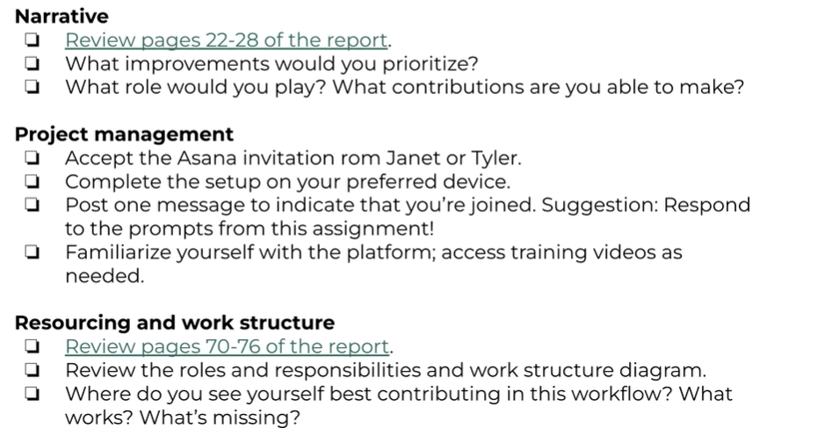

- Next call (1st Monday each month): March 6, 2023

