NAACCR Annual Business Meeting Minutes
Friday June 18, 2021
- Open Meeting and Welcome Randi Rycroft (ID)
  - Call to Order
  - Announcement of Quorum There is a minimum quorum needed of 25 and 57 voting delegates were present.
  - Call for New Business from the Membership

No new business was called for.
  - Appointments
    - 2021 Business Meeting Minutes Approval Committee – Updated by President

The following members were appointed:
- Lynn Giljahn (OH), Monique Hernandez (FL), and Georgia Yee (AZ)

- Minutes from 2020 Meeting Randi Rycroft
- Approved – Item approved prior to meeting.

- Election Results and Destruction of Ballots Randi Rycroft
- Approved – Item approved prior to meeting and were announced in the NAACCR Narrative. Delegates have approved for the destruction of the ballots.

- Confirmation of Nominating Committee Randi Rycroft
  - Members elected during vote. See attached report.

With the change in bylaws last year the Nominating Committee is now an elected committee.

- Announcement of Certification Results Randi Rycroft

The list of certified registries was included in the packet and slides of results were presented during the meeting. More detailed information regarding certification can be found here.
NAACCR Fit for Use for Survival/Prevalence Recognition
NAACCR Certification Year 2020 Gold & Silver

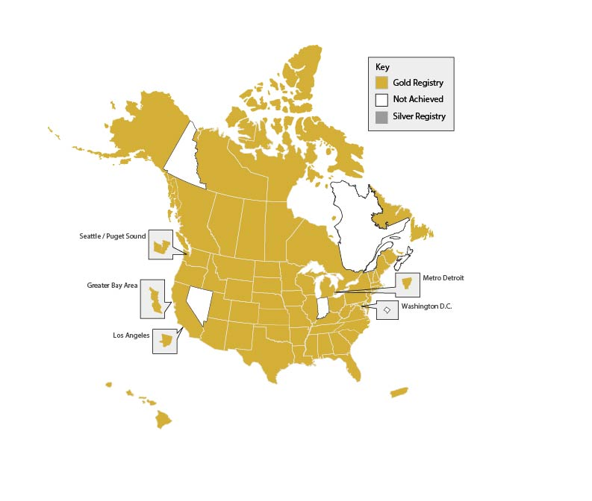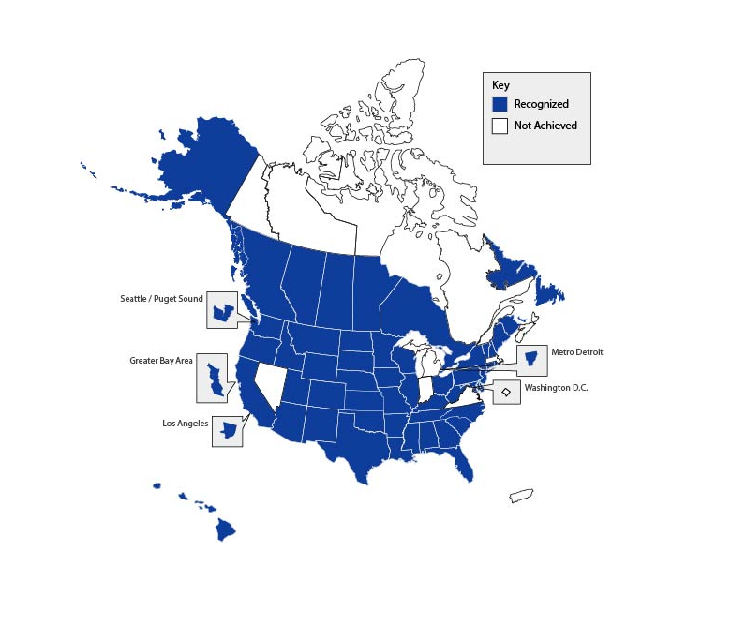

- Strategic Management Plan Update
  - Strategic Management Plan Process Angela Meisner (NM)/Sarah Nash (IA)

Angela and Sarah thanked consultant Ann Marie Hill for her guidance and input. They also thanked all the steering committees and chairs for their efforts.
    - A workgroup was formed and surveyed the NAACCR community for input on whether focus areas were still on track. These results were published in the NAACCR Narrative newsletter. For those who provided feedback at the town hall, if it is not incorporated into the SMP it was heard and may be included in future plans.
- Sarah thanked the Steering Committee chairs for the hard work in incorporating feedback into new goals and objectives.
- It was changed to a 3-year plan and focused on the strategic plan as opposed to a management plan.
- Board has approved proposed goals and objectives.
  - Strategic Management Plan 2021 – 2024 Randi Rycroft

Randi thanked Angela and Sarah for their hard work. She also thanked consultant Ann Marie Hill for her guidance and input.
- Final report is with the editor and should be posted to the NAACCR website next week.
- Past Strategic Management Plans can be found on the NAACCR website here Strategic Management Plan (naaccr.org)
- A history of how the SMP has evolved was created by Nan Stroup and will be available on the NAACCR site in the future.
- NAACCR’s formal mission can be found here About NAACCR
- Randi pointed out Strategic Alliances will now be called Strategic Planning and Alliances Steering Committee.

Steering Committee’s Next Steps
  - Develop work plans for the coming year and will be due at the end of June 2021.
  - Help identify metrics for tracking success and progress.
  - Review all work groups and task forces.
  - Strategic Planning and Alliances will revise team charter and recruit new members.

  - SMP Work Group Next 3 Years Winny Roshala (CA)

Winny thanked Randi, Angela and Sarah for their hard work and leadership. She stressed the SMP is a living document and can be modified as we go. Everyone is encouraged to utilize the plan and goals laid out for the next 3 years.
- Continue to incorporate clear strategy into the SMP.
- Identify at least one WOW initiative.
- Improve how we track and communicate our progress and successes.
- SMP WG will be tasked with monitoring progress.

- Highlights and Accomplishments
  - NAACCR Accomplishments Betsy Kohler

Betsy presented the highlights of NAACCR’s accomplishments over the past year.

Completion of Major Projects:
- Completed the NACDD/CDC project, Identify and Implement Best Practices for Cancer Registry Operations that resulted in two 250+page reports, several workshops, data summits, tip sheets, a new internal completeness measure, recommendations for modification of the existing measure, and several ancillary completeness indicators. There were 5 major projects this year that were part of the NACDD initiative: LEAN six-sigma analysis of electronic path reporting, building an interactive legislative data base and integrating it into the CARI Database, an auto-consolidation project (led by CDC), the development of 4 interactive workshops, and the development of the completeness estimates.
- Completed the multi-year ATSDR/Battelle/Camp Lejeune cancer incidence study which identified more than 30,000 matched cases for analysis. This study allowed us to test many aspects of the VPR type of study methodology and build ties with many registries.
New Initiatives:
- Launched the National Childhood Cancer Registry Project.
- Launched new interactive Coffee Talks, and workshops where registry staff can get together to exchange ideas about registry operations and innovative methods.
- Worked with Rutgers University (New Jersey) on developing an Undergraduate Certificate in Cancer Surveillance program under the Edward J. Bloustein School of Planning and Public Policy as a way to engage students in the Cancer Surveillance community and provide recommendations for program instructors.
- Established CiNA Research Network that is a core group that will help facilitate collaborative papers using CiNA as well as review data research protocols.
  - 3 initial projects: a description of CiNA, Incidence of rare cancers, and ABSM analysis
      - CiNA Research Network will work with Professional Development and MAP to support collaboration and/or mentorship among researchers wishing to use CiNA data but unfamiliar with cancer surveillance data.
- The NAACCR Member Ambassador Program (MAP) was officially launched in May 2021 with the primary goal of assisting NAACCR members who want to get involved but don’t know where to start. A MAP page, as well as a form, has been added to the NAACCR website to initiate the process.
- The SRD co-chairs formed the Interstate Case Ownership Task Force in collaboration with the RDU SC to develop rules for determining ownership of duplicate cases. The group began meeting in June 2020.
- Published a cancer surveillance/central registry centric issue of the Journal of Registry Management in collaboration with the National Cancer Registrars Association. We plan on doing this annually.
- Plan to draft a paper with a focus on what registries can do moving forward on a national level using NLP tools. Different approaches to the paper have been discussed. The paper will likely evaluate the current advances in NLP research, such as work emerging from the Department of Energy (DOE) and NCI collaboration. Topics such as uncertainly quantification and registry workflows will be considered. Goal will be to suggest a national strategy to move these developments forward to benefit all registries.

Notable Progress:
- List of NAACCR Talks—Reached 754 people.
8/28/2020 | Revised Common Rule for IRBs
9/2/2020 | The virtual Pooled Registry…and Beyond!
9/9/2020 | Utility, Strengths, and Limitations of Cancer Registry Data for Firefighter Cancer Research
9/30/2020 | Operations to Enhance Data Use & Research
10/7/2020 | Focus on Survival
10/21/2020 | Social Determinants of Health Part 1
10/28/2020 | Social Determinants of Health Part 2
11/4/2020 | Focus on Brain Tumors
12/2/2020 | Advanced Data Collection
3/23/2021 | Town Hall: NAACCR Strategic Management Plan 2021-2024
3/24/2021 | Sassafras! Reading and writing NAACCR V21 CML files using SAS
4/21/2021 | A Condensed Training for the Rate Stabilizing Tool Session 1
4/28/2021 | A Condensed Training for the Rate Stabilizing Tool Session 2
5/5/2021 | Refresh Your Knowledge: Requesting and Using NDI Linkages
5/26/2021 | Secondary Release of Cancer Registry Data
- Six new registries have joined the VPR, bringing the total number of participating registries up to 43 (representing 86.6% of the U.S. population plus Puerto Rico).
- Of the 43 participating registries, 31 are using the Templated IRB/Registry Application in lieu of their registry and/or IRB state-specific applications.
- Updated on-line query system with additional data visualization (CiNA*Explorer) to be released June 2021.
- NAACCR Volume II was released in August 2020, followed by several updates.
- NAAACCR Volume V was updated and was released in May 2020 and was revised in July. Summary of changes from version 4.0 to 5.0 was posted in December.

Collaborative Efforts:
- NAACCR leadership had an initial call with representatives from the American College of Radiologists (ACR). Their initial interest is in shepherding a proposed new data item through for population-level collection, but they also expressed interest in a longer term relationship between our two organizations.
- Continued our relationships with national organizations:
    - One Voice Against Cancer (OVAC) --NAACCR provided input to OVAC for their appropriations ask to increase funding for cancer registries and participated in a Hill Briefing on “Cancer Research: Challenges, Progress and the Role of Cancer Registries.” OVAC hosted a speaker panel to educate policy makers on the importance of cancer registries in cancer research and cancer control efforts.
    - Worked with OVAC on advocacy issues for cancer surveillance and research and spoke with two congressional offices.
    - Comprehensive Cancer Control National Partnership—NAACCR attends monthly calls and in-person meetings twice a year (which were held virtually this past year).
    - College of American Pathologists – CAP now has representatives on both the MLTG and HLSG.
- Joined Digital Bridge to work on improving electronic reporting from health care providers with public health and industry leaders. Cancer is the use case this year.

Business as Usual:
- Met all deliverables on all projects, grants, contracts and co-operative agreements despite the effects of COVID. Managed COVID related changes in workplace and social distancing.
- Successfully held the 2020 NAACCR Annual Conference virtually and prevented any financial penalties that may have resulted from exiting our contract with the Philadelphia hotel.
- Planned the NAACCR Summer Forum for 2021.
- Participated on many advisory panels including National Firefighters Registry and new study of military aviators mandated by Congress.
- Developing plans for a new membership management system that will modernize our functionality and provide more flexibility.
- Made substantial gains in NAACCR’s investment portfolio.
- Recognition of NAACCR Steering Committee Chairs and Liaisons Randi Rycroft

Randi thanked all the steering committee chairs and liaisons.

- Recognition of NAACCR Award Recipients presented earlier in conference Randi Rycroft
- Calum S. Muir - Frances E. Ross (KY) – For her steadfast dedication throughout her career to improving cancer surveillance in North America, for her generous contributions of service to NAACCR, for serving as a mentor and helping others find their voice, and for providing frank and honest leadership in establishing meaningful data standards.
- Constance L. Percy - Eric J. Feuer (MD), Joshua Sampson, Li Zhu (MD), Trevor Thompson (GA), Joe Zhou, Francis Boscoe for his or her contribution to the Statistical Expert Panel on Central Registry Completeness.

- Treasurer’s Report Randi Rycroft

Financial Oversight, Operations, Audit, Financial Status was submitted by Maria Schymura (NY), Treasurer and included in the packet. Randi thanked Maria Schymura for her years of service to NAACCR as treasurer. NAACCR has increased the total assets and liabilities are low. The organization can easily meet the business obligations each month and annually. Cash on hand is strong and investments are growing. Grant and contract activity is increasing. The balance sheet as of March 31, 2021 showed total assets being $2,752,247.37.

- Support of All Kinds by Sponsoring Member Organizations Randi Rycroft

Randi presented slides listing the NAACCR support of all kinds from member organizations for 2020-2021.

- Adjournment Randi Rycroft

Randi adjourned the meeting at approximately 11:19 am central time.

