GenEDITS Data Dictionary Update
The base dictionaries were final at the time of release of GenEDITS, but are subject to change over time and can be replaced in the GenEDITS Data Dictionary folder. To update the GenEDITS base dictionary go to the NAACCR XML page https://www.naaccr.org/xml-data-exchange-standard/

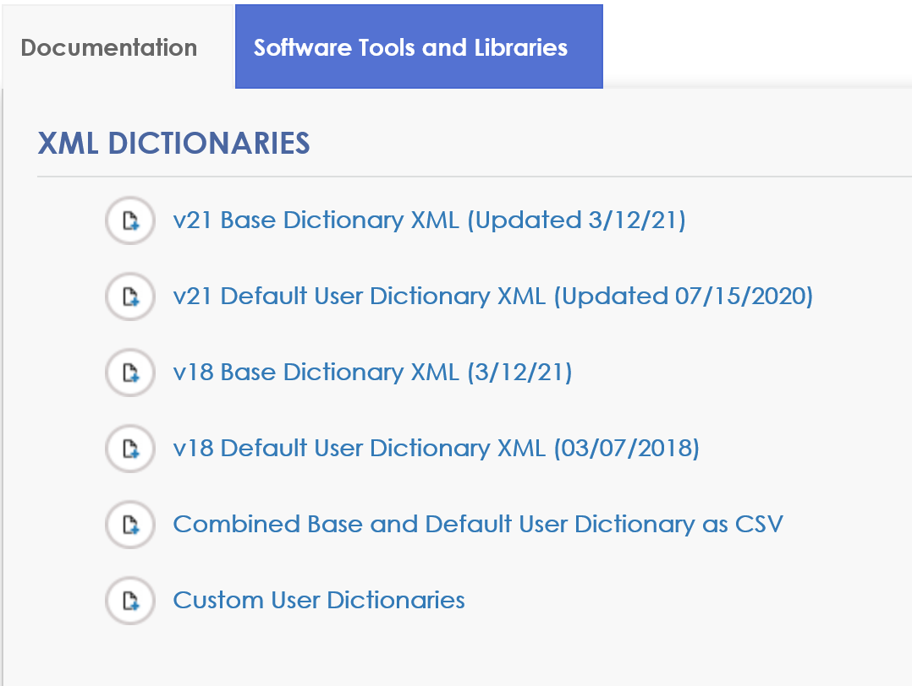

- Right click on the v21 Base Dictionary XML
- Click Save Link As (or similiar option depending on browser)
- Save the dictionary in the Base Dictionary folder
  - C:\RegPlus\EDITS50\GenEdits Plus\Data Dictionary
  - Will have the same name as previous data dictionary only date modified will be different. Save over the version in the folder.
If using IE, you will have to type in .xml after the file name.

- Make sure the Type of document is XML document (should not be TXT).
- Open the document and look at the Change Log to make sure the most recent update reflects the date on the NAACCR XML page

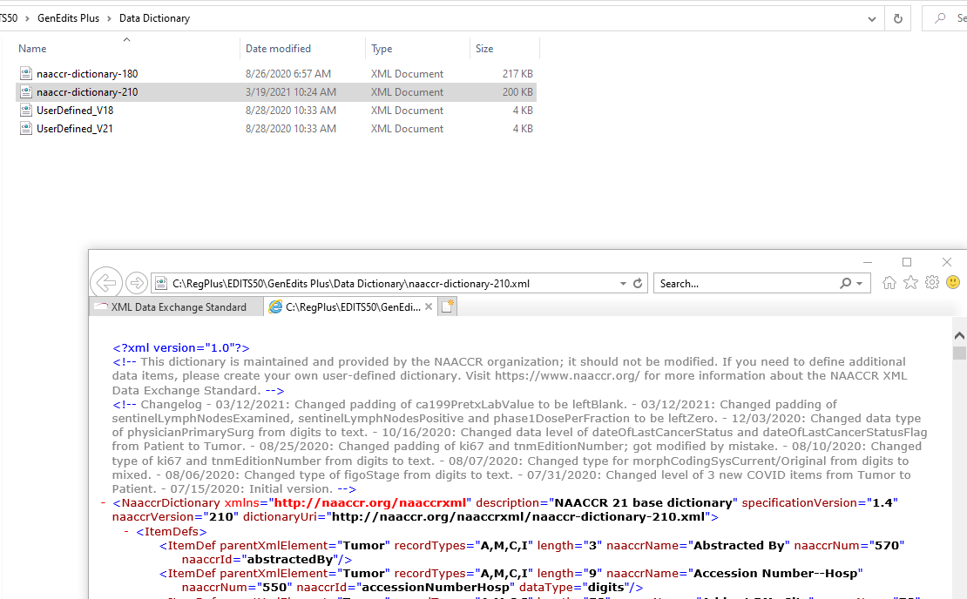

Why update your data dictionary?
Most recent update addressed a “padding issue”. Some data items did not justify correctly for use in GenEDITS. An edit will be triggered saying the field is not correctly justified even though the data is correct.
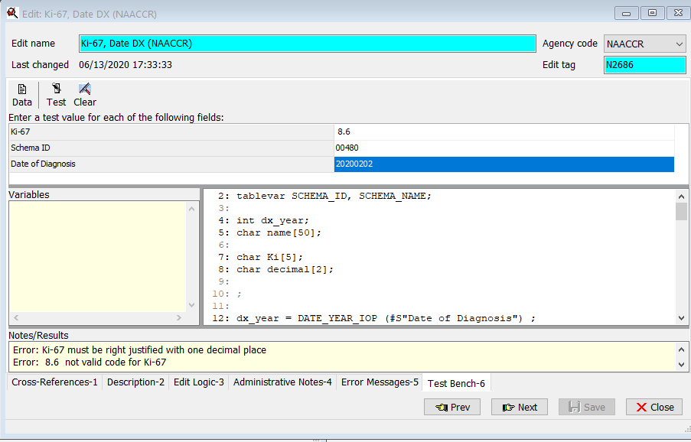
Extra space was added due to problem in data dictionary

